**Project Documentation**

**Project title:** Fitflex

**1.INTRODUCTION**

* **Project title:** Fitflex
* **Team ID :** NM2025TMID37583
* **Team leader:** JANSI RANI.G -jancyranijancyrani54@gmail.com
* **Team members**

1. AMBIKA.C – [chinnayanambika16@gmail.com](mailto:chinnayanambika16@gmail.com)
2. JENNITA .J- jennitajayaraj11@gmail.com
3. KALAIVANI.R- Kalaivanirkalaivanir2@gmail.com

**2.PROJECT OVERVIEW**

* **Purpose:**To apply theoretical knowledge from the course into a real-time project.
* **FEATU** BMI Calculator **RES:**

1. **User Login/Signup** – Secure account for each user.
2. **Workout Tracking** – Add and view daily exercises.
3. **Diet Tracking** – Record food intake and calories.
4. **BMI Calculator** – Check fitness level easily.

**3.ARUCHITECTURE**

1. **Frontend**

* Users interact with the app/website.
* Can enter workout, diet, and view reports.

1. **Backend**

* Handles user requests (login, add data, fetch progress).
* Processes BMI, calories, and workout logs.

**3.Database**

* Stores user details, workout history, diet logs, BMI values.

**4.SET UP INSTRUCTIONS:**

**1. Install Required Software**

* Install [Python / Java / Node.js] (based on your project stack).Install a code editor like VS Code / Eclipse / Android studio

**2.Download**

* Copy the project files to your computer.

**Git clone <repository-link>**

**3.Install Dependencies**

For Node.js:

**Npm install**

**4.Setup Database**

Create a database (MySQL / MongoDB / Firebase).Import the provided SQL script (if using MySQL).

**5.Run the Project**

**Node.js:** npm start

**6.Access the application**

Open the mobile app on your device.

**5.FOLDER STRUCTURE**

**If Backend (Node.js + Express/Django / Spring Boot)**

Fitflex-backend/

-src/

Config/

# Env configs

Routes/

#API routes

Controllers/

# Request handlers

-models/

#DB schemas

Services/

#Business logic

Middlewares/

#Auth, logging, validation

-database/

#DB connection, migrations, seeds

Utils/

#Utility functions

App.js/server.js # App entry

-tests/

#Test cases

-eny

-package.json

**If Full-stack (Frontend + Backend)**

**Fitflex/**

-frontend/

#React/Next.js app

-backend/

#Node.js/Express or Django app

-mobile/

#(Optional) React Native / Flutter app

-docs/

#Documentation

-decker/

#Docker configs if needed

-scripts/

#Automation scripts

-README.md

**6.PROJECT FLOW OF FITFLEX**

**1. User Registration & Login**

* New users create an account.
* Existing users log in securely.

**2. Dashboard**

Shows daily summary (calories, workouts, BMI).

**3. Workout Tracking**

User adds exercise type, duration, and calories burned.

**4. Diet Tracking**

User records meals and calorie intake.

**5. BMI Calculator**

User enters height and weight → BMI result displayed.

**6. Progress Report**

Weekly/monthly charts of fitness progress.

**7. Notifications / Reminders (Optional)**

Alerts for workouts, diet, or goals.

**Flow diagram**

Start → Login/Signup → Dashboard

→ [Workout Tracking]

→ [Diet Tracking]

→ [BMI Calculator]

→ [Progress Reports]

End

**7.TECHNOLOGY FOR FITFLEX**

**1. Frontend (Web App)**

Framework: React.js (or Next.js for SSR & SEO)

Styling: Tailwind CSS / Material UI / Bootstrap

State Management: Redux Toolkit or React Context API

API Calls: Axios / Fetch API

Charts (progress tracking): Recharts/Chart.Js

**2. Backend (API)**

Language: Node.js with Express.js

(Alternative: Python Django REST Framework)

Authentication: JWT (JSON Web Token) for secure login

Validation: Joi / Yup middleware

API Documentation: Swagger / Postman

**8. SIMPLE USER INTERFACE**

1. Login / Signup Page – Secure entry for new and existing users.

2.Dashboard – Overview of daily calories, workouts, and progress.

3.Workout Page – Add exercises with time and calories burned.

4.Diet Page – Record meals and calorie intake.

5.BMI Calculator Page – Enter height and weight to calculate BMI.

6.Reports Page – Graphs and charts showing weekly/monthly progress.

**9.SCREENSHOTS**

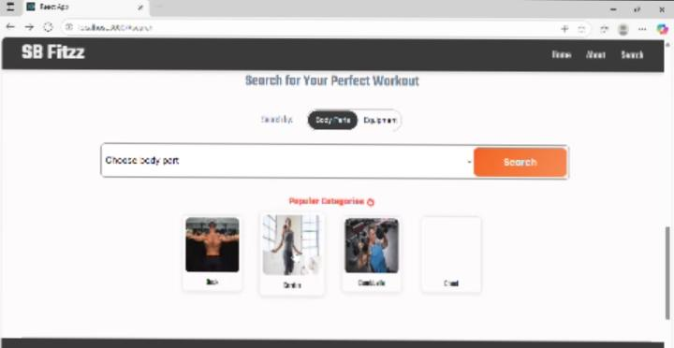

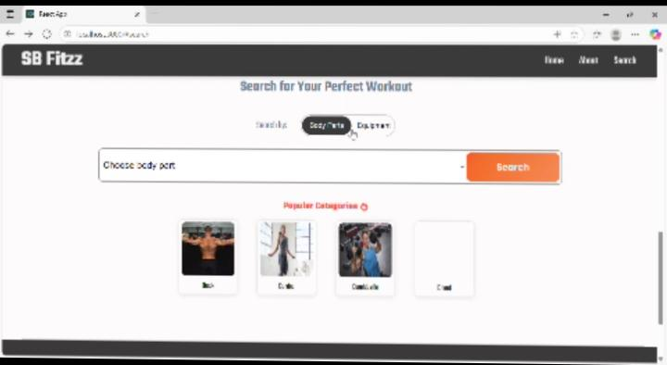

**10.CONCLUSION**

FitFlex is a user-friendly fitness app that helps users track workouts, monitor nutrition, and see their progress. The project provides a simple and interactive interface and encourages a healthy lifestyle. It is scalable and can be improved with new features in the future.